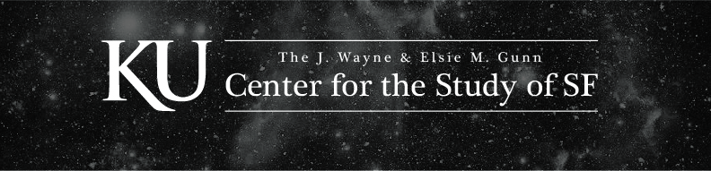

CALL FOR PAPERS

The J. Wayne and Elsie M. Gunn Center for the Study of Science Fiction is excited to announce our 2nd Annual Sturgeon Symposium (Wed. 9/20 – Fri. 9/22/2023), celebrating the 30th anniversary of Octavia Butler's groundbreaking novel, The Parable of the Sower. As KU's choice for the 2023 Common Book program, this novel is a powerful inspiration for our Symposium's theme, "Fantastic Worlds, Fraught Futures."
The Symposium will feature Noël Sturgeon's presentation of the Theodore Sturgeon Memorial Award for best science fiction short story and a reading from this year's winner. This year, the Symposium will include all-virtual sessions scheduled for Wednesday and in-person sessions on Thursday and Friday. The presentation of the Award and the reading by the winner will be a hybrid in-person/online event, and we intend to broadcast the session for those who register and cannot be at the Symposium in person. We believe that this structure offers an opportunity for a broader community to engage with the work of scholars, practitioners, and enthusiasts of SF (science fiction, fantasy, horror, and other speculative modes)..

The CSSF celebrates the diverse community of students, scholars, creators, and fans who engage with speculative modes, challenging our conceptions of what is possible. As Octavia Butler writes in Parable of the Sower, "All that you touch, / You Change. / All that you Change / Changes you." Butler's work reminds us of the transformative power of speculative fiction and its ability to inspire change and community in the face of the unknown.
We welcome all individual papers, fully formed panels, and roundtables exploring "Fantastic Worlds, Fraught Futures," particularly those prioritizing collaboration and dialogue across communities, and creative work from Indian Nations, such as the Kaw, Osage, and others whose homelands KU stands. Please note that, while we will make the Symposium available virtually, virtual presenters will be grouped together; unlike 2022, we will not be organizing panels that mix virtual and in-person presentations.
Some possible topics for exploration include:

• SF pedagogy
• Climate fiction
• SF and revolution
• Maternity
• Artificial intelligence
• Machines in fiction
• Digital SF
• Virtual realities
• Music and SF
• Weird fiction
• Post-human futures
• SF and narratives of escape/resistance
• Emerging technologies
• SF and war
• Animals and SF

In addition to the award presentation and programming developed from your submissions, the Symposium will include a roundtable discussion on the present and future of SF, a pedagogy panel on how SF is being taught, and a creative writing workshop.

Please email proposals to the Gunn Center, sfcenter@ku.edu, by April 17, 2023. Notifications will be sent out in late May.
For more detailed information about the symposium, including travel information and lodging options, please visit the CSSF website: https://sfcenter.ku.edu/sturgeon-symposium.

